SCUBA-2 Block Specification
Fibre_rx

September 28, 2005
Table of Contents

1. Block Overview 3
1.1 Block Location and Block Interface Within System 3
1.2 Block Functionality / Features 3
1.3 Dataflow Block Diagram 3
2. Block Interfaces 4
2.1 Interface Signal Description 4
2.2 Interface Protocol and Timing 4
3. High-Level Description 6
3.1 Controller ASM Chart 6

Block Overview

Block Location and Block Interface Within System
This block implements the interface to the Hotlink fibre-optic communication link. It is used on the clock card and connects to the cmd_translator module inside issue_reply.

Block Functionality / Features
This block implements a 32-bit interface, giving the appearance of a 32-bit wide communications link when in fact the physical layer is only 8-bits wide. In addition, the block implements a clock domain crossing by using a dual-clock FIFO. Finally, this block implements an asynchronous handshaking protocol to control the flow of data, thus ensuring that the data is removed only when it has been latched (and acknowledged) by the receiving block.

Dataflow Block Diagram

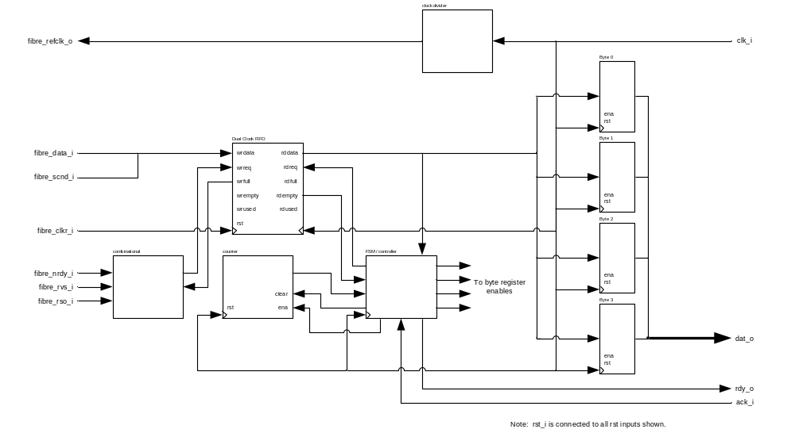

Block Interfaces

Interface Signal Description
- Interface Signals
Signal | Description | Direction
Global Signals
clk_i | Global clock. | in
rst_i | Global reset. | in
Host Interface Signals
dat_o | 32-bit data word received over Hotlink. | out
rdy_o | Data ready signal. Indicates that the data on dat_o is valid. | out
ack_i | Data acknowledge signal. Indicates that the data on dat_o has been latched by the receiving block. | in
Fibre Interface Signals
fibre_refclk_o | 25 MHz Hotlink receiver reference clock. | out
fibre_clkr_i | 25 MHz Hotlink recovered receiver clock. | in
fibre_data_i | 8-bit data received over Hotlink. | in
fibre_sc_nd_i | Special character flag. Indicates whether the data on fibre_data_i is data (sc_nd = ‘0’) or control (sc_nd = ‘1’). | in
fibre_nrdy_i | Hotlink data ready flag. Indicates that the data on fibre_data_i is valid. Active low. | in
fibre_rvs_i | Hotlink received violation symbol. Indicates that the last data received was not a valid code. | in
fibre_rso_i | Hotlink carrier detect. Indicates that the fibre optic cable is connected. | in

Interface Protocol and Timing
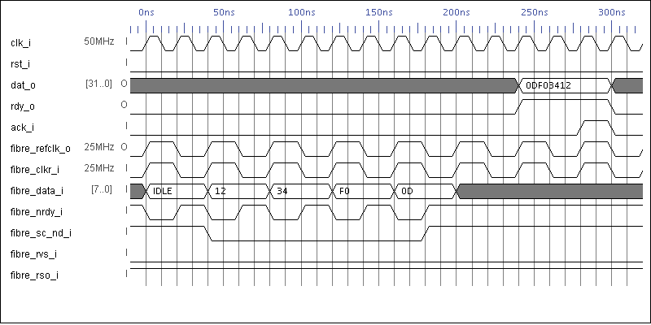

High-Level Description

Controller ASM Chart

reset

idle

byte_count_clr

buf_empty
T

F
buf_read

buf_data = IDLE
buf_empty
buf_read
check_frame
F
T
T
F
To load_bytes state
(see next page)
From ready state
(see next page)

Figure 1. IDLE and CHECK_FRAME states

buf_data = special
buf_read

F
T
T
T

F

F

rdy_o
ack_i
buf_empty
count = 0
count = 1
count = 2
byte0_ld
byte1_ld
byte2_ld
byte3_ld
buf_read
count_ena
ready
load_bytes
T
F
From check_frame state
(see previous page)
F
F
T
To idle state
(see previous page)
T

Figure 2. LOAD_BYTES and READY states

